**Q17. Weather Observation Station 12**

Query the list of CITY names from STATION that do not start with vowels and do not end with vowels. Your result cannot contain duplicates.

The STATION table is described as follows: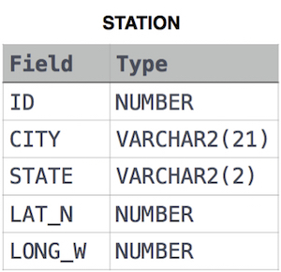

Ans.

SELECT DISTINCT CITY

FROM STATION

WHERE LEFT(CITY, 1) NOT IN ('A', 'E', 'I', 'O', 'U')

AND RIGHT(CITY, 1) NOT IN ('A', 'E', 'I', 'O', 'U');

**OR**

SELECT DISTINCT(CITY)

FROM STATION

WHERE LOWER(CITY) REGEXP '^[^aeiou]' AND

LOWER(CITY) REGEXP '[^aeiou]$'